**<--Start Game-->**

**Intro Cutscene {**

**BLACK SCREEN**

**CUT IN**

**[SFX: Sounds of bow strings stretching, fire arrows burning, Bow shoot sounds]**

**[Soundtrack ref:** [**Khotun Khan**](https://open.spotify.com/track/3vWCymsItfF3itickaURHA?si=pjJAG1AmTjKjrlG27CTPSA)**]**

**Camera:** A shot of a few goblin soldier arms, as they reload fire arrows onto their bows,

and then firing them.

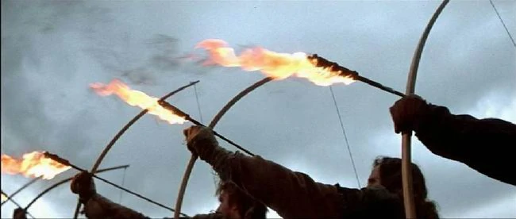

**CUT**

**[SFX: Arrow hitting ground, fire burning, oil catching flame”Whoom”]**

**[VFX: Fire Spreading]**

**Camera:** A low shot of the front porch facing the goblin soldier’s and their commander,

Focus on goblin army, then blur the goblin army to focus on the oil on the ground, arrows

hit the ground immediately after.

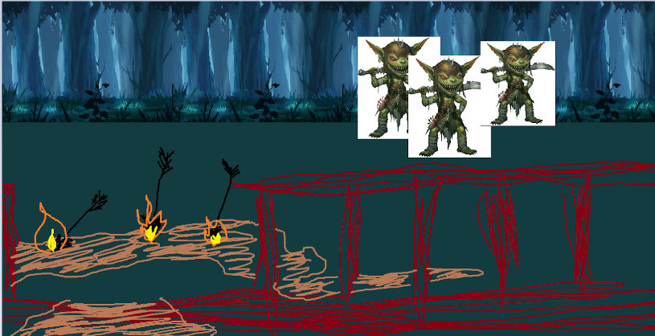

**CUT**

**[SFX: Fire burning in the distance, maybe wood structures falling apart sound]**

**Camera:** A shot of the goblin commander’s face watching the house burn. The fire

burning reflecting through his eyes. Very stern look on his face.

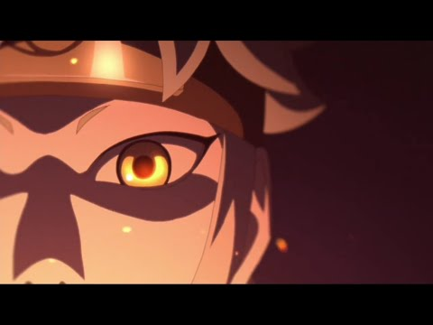

**CUT**

**[SFX: Wooden door breaching sound, Flame sounds, Wooden rubble sounds]**

**Camera:** A shot showing at the burning house, over the shoulders of the goblin soldiers

And the commander.

**Musashi:** Breaks open the door running out, holding Yuudachi tight, covering her with his

Mantle/cape/hood. He stops after a few steps just in front of the house and knelt down,

Opening the mantle letting Yuudachi breathe, he had his hand on her shoulder/back.

**Yuudachi:** She coughs heavily a few times.

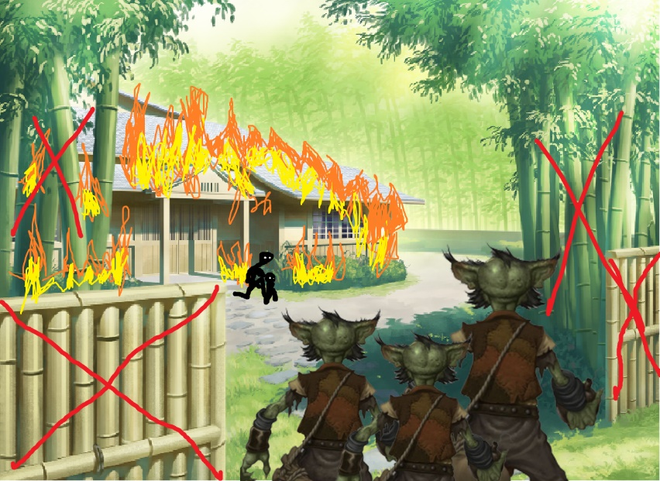

**CUT**

**[SFX: Standing Up footsteps, footsteps walk]**

**Camera:** A shot from the back of the hunter and Yuudachi kneeling down, looking at the

Goblin Commander talking.

**Yuudachi:** panting.

**Goblin Commander:** “Finally, you both showed up.”, said with a heavy goblin sound.

**Musashi:** Stands up, starts walking ahead of Yuudachi.

**Goblin Commander:** “I’ve been looking for you in a long time. You humans sure can be

Annoying. HA HA HA.”

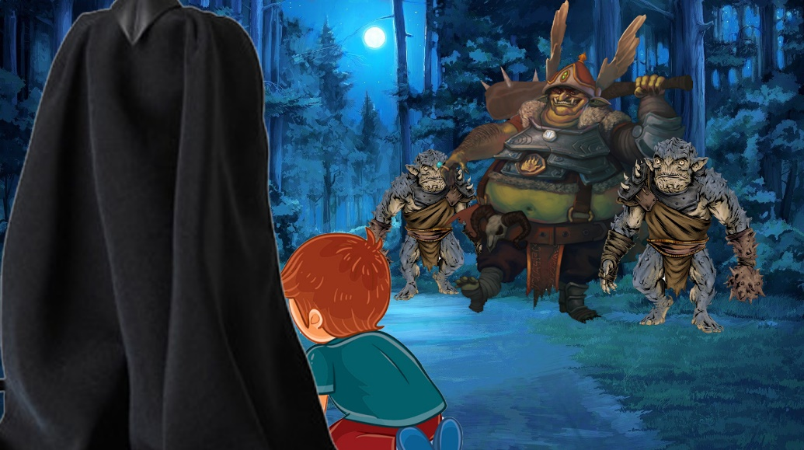

**CUT**

**[SFX: footsteps, draw sword/katana]**

**Camera:**

**Musashi:** Walks ahead of Yuudachi. Stops after a few steps.

**Goblin Commander:** “No matter. You won’t be causing any more problems after I

kill you. HA HA HA.”

**Yuudachi:** Still panting.

**Musashi:** “Are you okay?” (Dai jou bu ka?)

**Yuudachi:** She gathers herself, stands up. “mhm” (meaning yes).

**Musashi:** Puts his hand on his katana. “No matter what happens, stay behind me. Do you

Understand?”. He says to Yuudachi with a low voice.

**Yuudachi:** “Got it.” (Wa ka ta).

**Musashi:** Pulls out his katana/sword. Ready to fight.

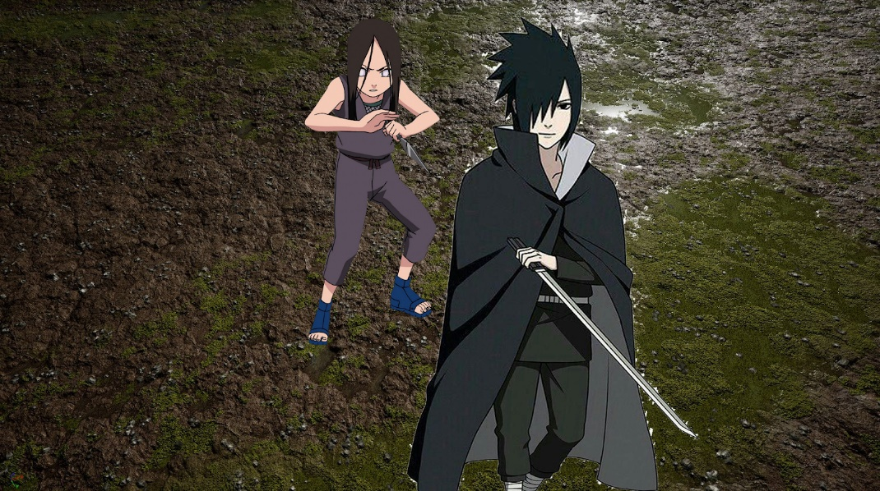

**}**

**Fight with goblin soldiers and Commander (easy mode) {**

**Win Condition:**  Kill all Goblin Soldiers

**Lose Condition:** One of the characters dies.

Musashi and Yuudachi versus the Goblin Commander and his soldiers, maybe 5 - 10

Soldiers.

This is where the tutorial happens. First on screen prompt is the movement (Left stick to

move). The game will slow down time on the first goblin

Attack, show prompt on screen (Press LB to Block). Right after the first block, the game

will slow down time again, this time prompting to attack (Press RB to Attack). Once the tutorial is done. The player and Yuudachi will have to kill all the goblin soldiers. The Commander will also join the fight, but is defensive and only has basic attacks. Any attacks will be deflected by the commander at this point. The Commander cannot die during this part.

This part is completed when all goblin soldiers are killed. And then the commander transforms into his second form and this marks the final phase which is the boss fight.

**}**

**Boss Fight {**

**Win Condition:** Empty Boss HP

**Lose Condition:** One of the characters die.

Once all goblin soldiers are dead, The boss will get more serious. This part is the final

bossfight.

His attacks are heavy and fast, his stamina is more than normal.

The Fight ends when Boss HP reaches 0.

It will trigger the ending cutscene, in which Musashi kills the commander, but at the cost of his life, protecting Yuudachi.

**}**

**Ending Cutscene {**

**[SFX: sword hit, human footsteps, heavy footsteps, cloth sound, sword swing ]**

**Camera:** A shot of Musashi slashing the goblin commander. Camera is shaking through

The whole sequence.

**Musashi:** “Hueh!”

**SFX:** “Sraak!”, sword slash body sound

**Goblin Commander:** “Uarghh..”.

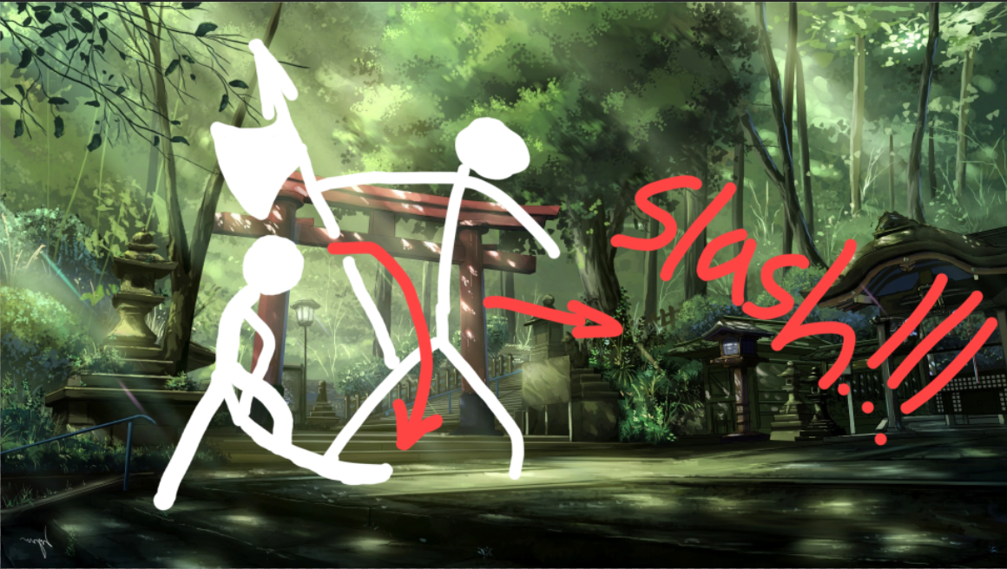

**Goblin Commander:** Gets knocked back a few steps then was brought to his knees.

**Musashi:** Runs towards the commander then does a jumping slash, “Hiya!”.

**Camera:** Cut the shot when Musashi is mid air.

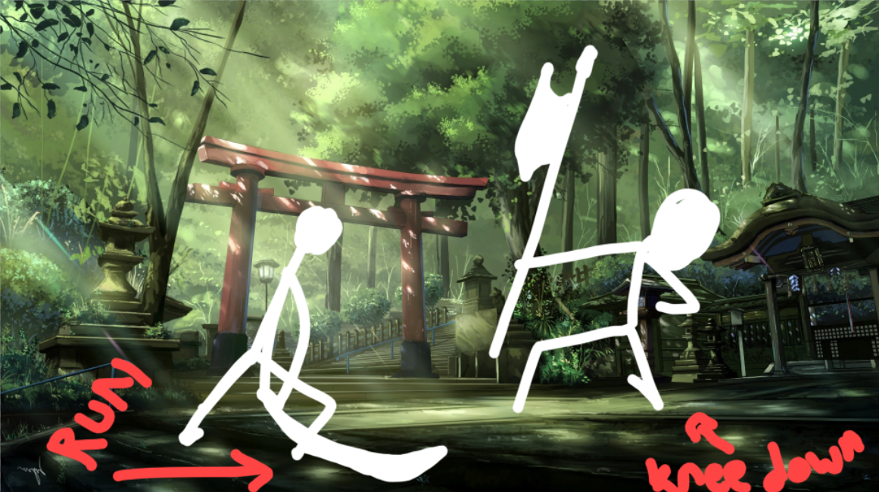

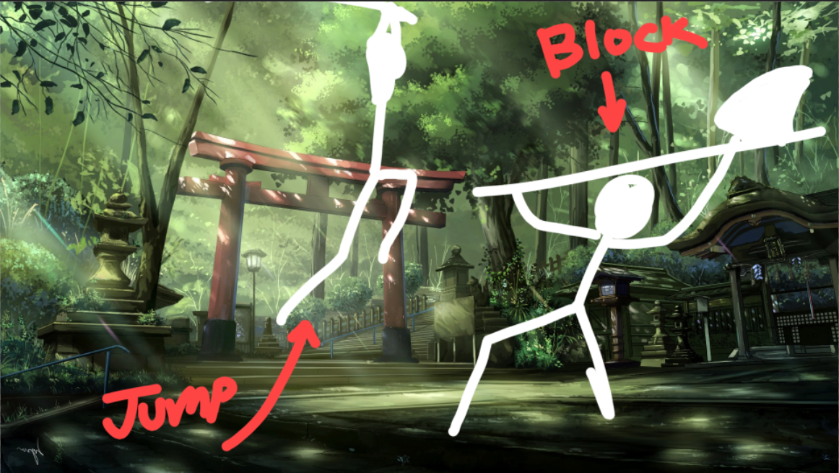

**CUT**

**[SFX: Wood breaking, staff spinning sound, blunt weapon hit]**

**Goblin Commander:** “Hmph!”, Blocks the attack over his head using his weapon. His

weapon breaks.

**SFX:** “Crackk!”, sound of the boss’s weapon breaking

**Musashi:** “Hu UH!”,short gasp.

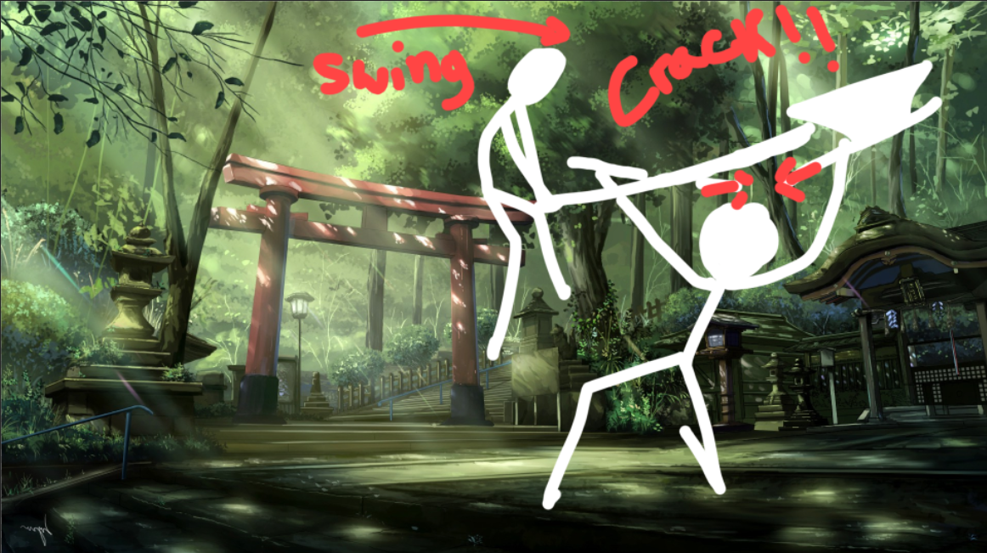

**Goblin Commander:** “Hmphh!!”, spins the lower half of his weapon, and hits Musashi

while still in the air (SFX: “Bam!”, blunt weapon hit). His weapon is a halberd, the top of the weapon is lethal, while the lower half is just a staff, blunt, not lethal. He uses the lower half to hit Musashi.

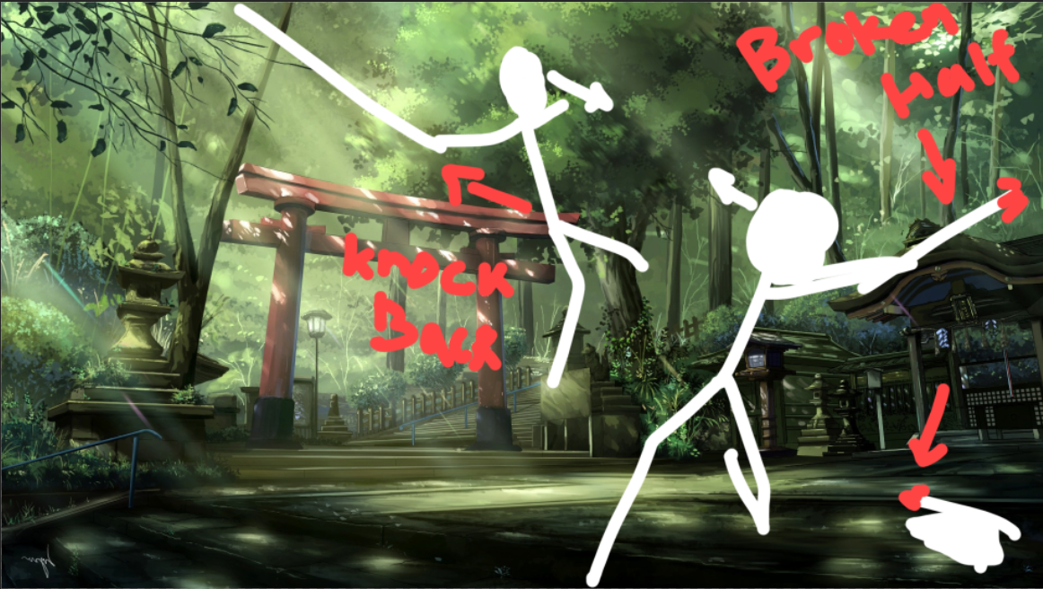

**Musashi:** got hit mid air and was sent flying, dropping his katana mid air. Then slammed on to the ground.

**SFX:** “Bruakk!”, The sound of Musashi’s body hitting the ground

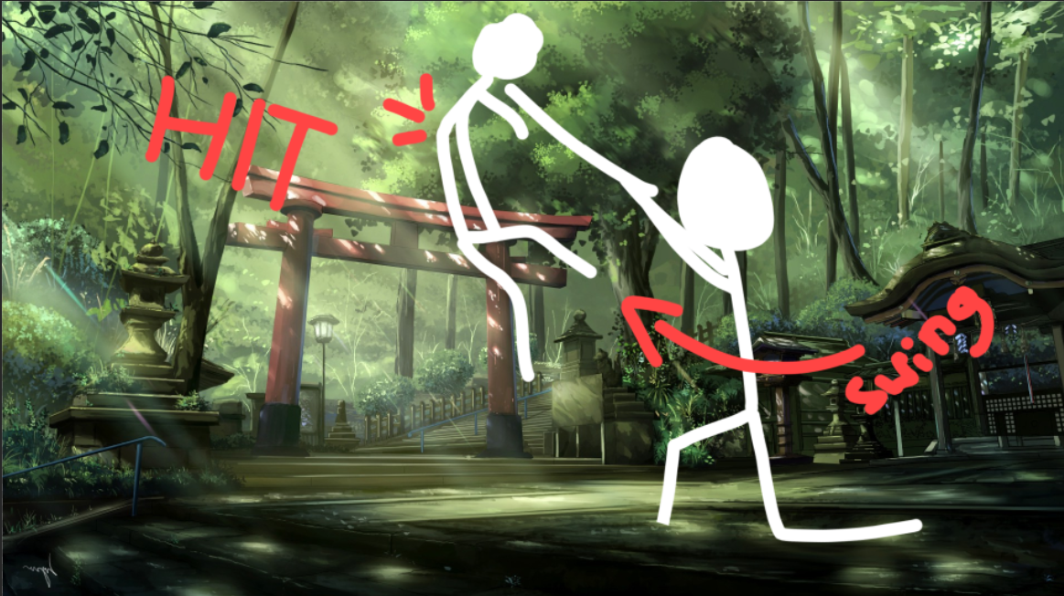

**CUT**

**[SFX: Sword pick up, heavy footsteps]**

**Camera:** A close up shot of Yuudachi, worrying about Musashi.

**Yuudachi:** “Musashii!!”, Screams in worry, looking at musashi’s direction.

**Goblin Commander:** Picks up the sharp end of his halberd. “Now then..” (Sa te).

Starts walking towards Yuudachi.



**Yuudachi:** “Hu Uh..”, Short gasp, in fear. Looks at the Commander’s direction

**Goblin Commander:** “That’s one down. All that’s left is you, little girl. HA HA HA. Now now, don’t be scared, it will be over soon.”.

**Yuudachi:** Scared sounds, trembling.



**CUT**

**[SFX: Heavy weapon sweeps]**

**Camera:** A shot of the Commander thrusting his weapon towards Yuudachi.

**Goblin Commander:** “Huarrghh..”, He thrusts his weapon towards Yuudachi.



**CUT**

**[SFX: Heavy weapon sweeps, Heavy weapon hit bloody]**

**Camera:** A front shot of Yuudachi, trembling and panicking.

**Yuudachi:** Scare/Panic Sounds intensifies.

**SFX:** “Whooosh..”, The sound of the commander’s weapon being thrusted.

**Yuudachi:** “Umph!!”, moments before the hit lands, she closes her eyes and looks away to the left.

**SFX:** “Chhrroott!!”, the sound of a weapon piercing through a body.



**CUT OUT**

**BLACK SCREEN (few seconds)**

**CUT IN**

**Camera:** A shot of Yuudachi’s face, with her eyes closed.

**Yuudachi:** “H..Huh..”, slowly opening her eyes, realizes she is still alive.

**Yuudachi:** Slowly looks forward.

**Yuudachi:** Eyes widening, “Hu Uuh”, deep gasp, shocked, sad.



**CUT**

**[SFX: Big Reveal Sound, wind sounds, blood dripping, blood in mouth, footstep]**

**Camera:** A back shot of Musashi, taking the hit. Shows Yuudachi on the side

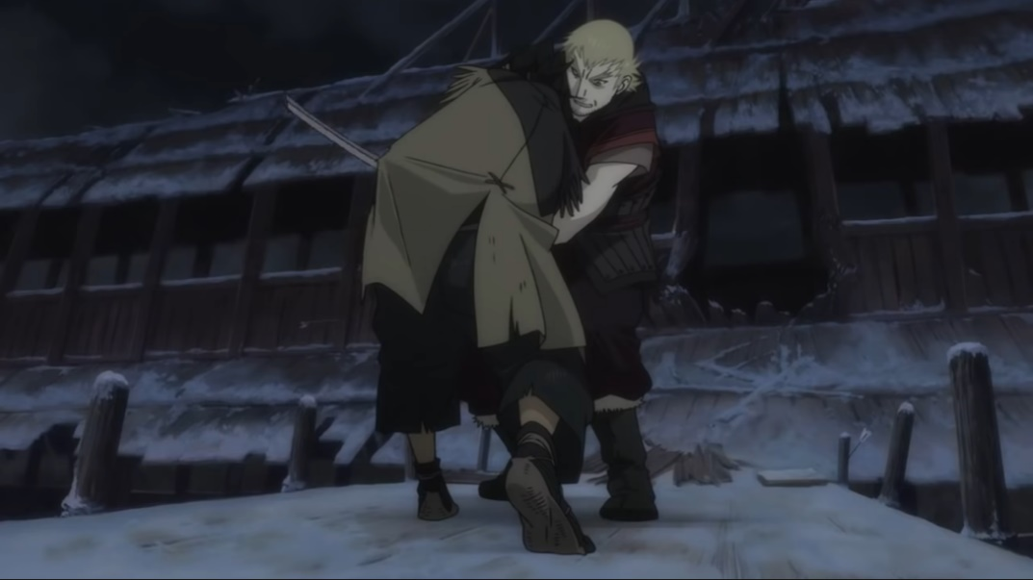

**Camera:** A similar shot of a brief flashback, in sepia, of Yuudachi’s real parents. Protecting her.

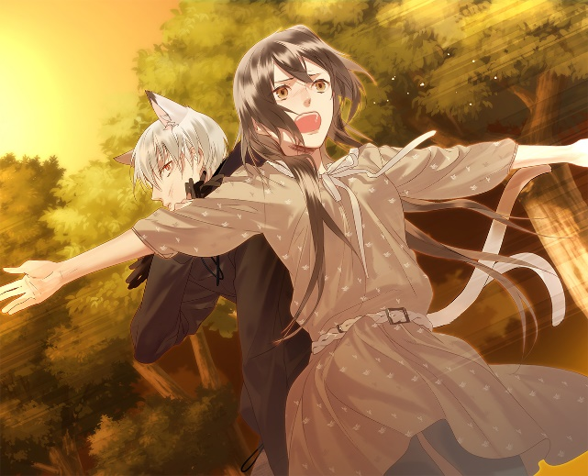

**Camera:** Back to Musashi.

**Yuudachi:** “M..Musashi!!!”

**Goblin Commander:** “Na..Ni..Uaghh”, Blood in mouth sound. He falls to the side. Dead.

**Musashi:** Falls to his knees. Tips to his left side.

**Yuudachi:** “Musashi!!”. Runs to catch Musashi as he is falling.





**CUT**

**[SFX: Footsteps, Sliding on mud, body falling into arms sound]**

**Yuudachi:** Catches Musashi as he is falling. Kneels down, lowering Musashi’s head onto her lap.



**CUT**

**Camera:** A high angleshot of Yuudachi holding Musashi.

**Yuudachi:** “Why..?” (Nande..?). Said with a soft crying tone. Sobbing afterwards.

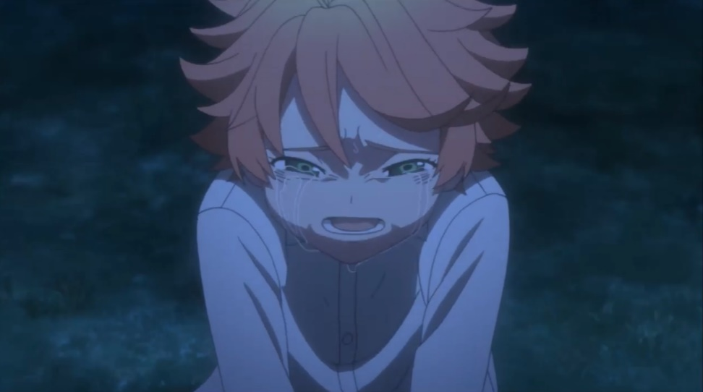

**CUT**

**Camera:** Side face shot of Musashi.

**Yuudachi:** Still sobbing.

**Musashi:** “I..failed..protecting..my family once. I..can’t..let it happen..again.. uugh ”, very weak, on the brink of losing consciousness, in pain.

**Yuudachi:** sobbing intensifies.

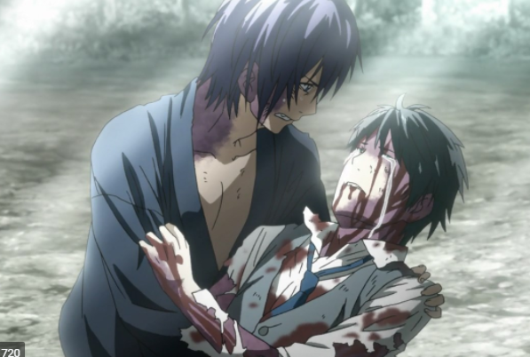

**CUT**

**Camera:** A low angle shot of Yuudachi, from the point of view of Musashi.

**Musashi:** “It looks like..I did it..this time..”

**Yuudachi:** sobbing even more.

**Musashi:** “Ughh…...I guess..this is the end for me..”

**Yuudachi:** sobbing even harder, crying, “Please..Stop saying these things..”.

**Musashi:** “You’ve..grown..to be..a strong young woman…...and I’m sure..you will get ..even stronger..”

**Musashi:** “Remember…..always..stay..alert…..be.. as kind..as you always were….help..people..along the way..”

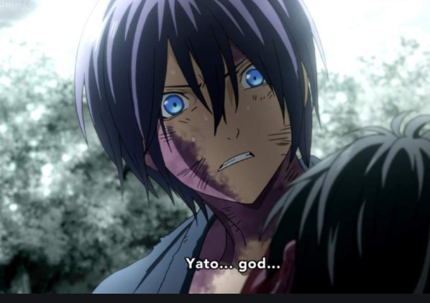

**CUT**

**[SFX: water drops on the ground, rain sounds]**

**Camera:** A side shot of Musashi’s left hand, laying on the ground.

**Musashi:** “Don’t forget..this old man…….I will.. be watching you..Always…...Yuu..da..chi………..”

**Yuudachi:** “Hu uh”, crying and gasping.

**Yuudachi:** She bends over her head touching Musashi’s head, crying

**SFX:** Water drops start falling from the sky. One….two..three drops, then it rains.

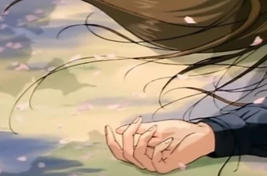

**CUT**

**Camera:** A high angle shot of Yuudachi holding Musashi under the rain, crying. The camera continuously zooms out, getting higher and higher, further and further away from those two.

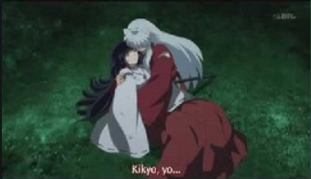

**FADE OUT**

**BLACK SCREEN**

**}**

**<--Game End-->**